**KATHFORD INTERNATIONAL COLLEGE OF ENGINEERING AND MANAGEMENT**

**Balkumari, Lalitpur**

**Affiliated to Tribhuvan University**

**Institute of Science and Technology**

**A Project Report on**

**CONTACT MANAGER**

**Submitted to**

**Department of Computer Science and Information Technology**

**Kathford International College of Engineering and Management**

***In Partial Fulfillment for the third semester course Object Oriented Programming (CSC-202) of Bachelor of Science in Computer Science and Information Technology (B.Sc.CSIT)***

**Under Supervision of**

Mr. Bhes Bahadur Thapa

(Lecturer, B.Sc.CSIT, Kathford College)

**Submitted By:**

Ashish Shrestha (5)

Bishal Thapa Shrestha (11)

Namkong Hang Kirat (21)

Neha Adhikari (22)

March 2017

**Kathford International College of Engineering and Management Balkumari, Lalitpur**

**LETTER OF APPROVAL**

This is to certify that this project prepared by Ashish Shrestha, Bishal Thapa Shrestha, Namkong Hang Kirat, Neha Adhikari entitled “**CONTACT MANAGER**” in partial fulfillment of the requirements for the third semester course **Object Oriented Programming (CSC-202)** of B.Sc. in Computer Science and Information Technology has been well studied. In our opinion it is satisfactory in the scope and quality as a project for the required subject.

………….………………. ………….……………….

Project Supervisor HoD of Computer Science and Technology

Kathford International College of Kathford International College of

Engineering and Management Engineering and Management

………………………….. …………………………..

SIGNATURE SIGNATURE

External Examiner Internal Examiner

**Kathford International College of Engineering and Management**

**Balkumari, Lalitpur**

**Supervisor’s Recommendation**

I hereby recommend that this project prepared under my supervision by Ashish Shrestha, Bishal Thapa Shrestha, Namkong Hang Kirat, Neha Adhikari entitled “**CONTACT MANAGER**” in partial fulfillment of the requirements for the third semester course **Object Oriented Programming (CSC-202)** of B.Sc. in Computer Science and Information Technology be processed for evaluation.

………………………...

Project Supervisor

Kathford International College of

Engineering and Management.

**ABSTRACT**

“CONTACT MANAGER” is a simple project for managing contact details. It can be used by any organization and individual to save important contact information of personnel, secured in a database.

Different contact management system has been made digital through several programming appeals today in order to make the system easy, efficient and comprehensible.

So we have thought of designing this project, **CONTACT MANAGER** is based on C++ language. With knowledge of unambiguous syntax commonly used in C++ will make this project completely understandable and easy to implement.

**ACKNOWLEDGMENT**

We are very much thankful to the Department of Computer Science and Information Technology, Kathford International College of Engineering and Management for accepting our report proposal on “CONTACT MANAGER” and granting us the opportunity of work undertaken. We express our earnest gratitude for providing us with all essential cooperation, valuable suggestion and the necessary resources during all the quarters of the completion of the report.

For the accomplishment of this report, a number of people have become a part of it. Firstly, we are deeply indebted to our Supervisor and HoD of CSIT for their kind support, coordination and valuable supervision from starting to end of this report without which this report could not come in this form.

We are also thankful to our friends who have contributed directly or indirectly in the accomplishment of our report.

We would also like to acknowledge and extend our gratitude to everyone for his/her support and encouragement.

**CONTENTS**

**Contents Page Number**

INTRODUCTION 1 OBJECTIVES AND METHODOLOGY 2 SCOPE AND LIMITATIONS 3 IMPLEMENTATION

1. Algorithm 4-18
2. Flowchart 19-20
3. Header Files 21
4. Structure 21
5. User-defined functions 22

CONCLUSION AND ENHANCEMENTS 23

APPENDICES 24-29

SOURCE CODE 30-98

REFERENCES AND BIBLIOGRAPHY

**INTRODUCTION**

**CONTACT MANAGER**

This is a simple project to manage contact details. It can be used by any organization and individual to save important contact information of personnel, secured in a database. This will help any organization and individual to manage contacts accordingly.

Contact Management System is a program based on C++ programming. This project uses file handling methodologies to store contact information of people in a local file. This program is console based. The program uses Command Line Interface (CLI) to interact with the user. Even though CLI is not much user friendly, we have made this program as simple as possible so as to improve the user experience.

The aim of this project is to implement a contact management system which is easy to use and is suitable for every individual and organization to manage contact details.

**PROBLEM STATEMENT**

Managing contact is difficult using traditional methods. Using a manual system is challenging as the records can be scattered, can be redundant and may be very time consuming. All these problems are solved using this project. Throughout the project the focus has been on keeping records in an easy and intelligible manner.

“Contact manager” is an automated version of manual contact details and using this software means eliminating the tedious physical transaction records on paper and making it digital and easier. The main objective of this program is to store contact information in a convenient manner so that it can be retrieved anytime hence solving the problem.

1

**OBJECTIVES AND METHODOLOGY**

**OBJECTIVE**

General:

* The main purpose of this project is to help any user to manage contact details.
* It will facilitate keeping all the records of contacts as Name, Landline number and Cell phone number and email address.
* So, all the contact details will be managed and can be easily available when needed.

Specific:

* To allow the user to enter and save the contact details and to also allow the user to edit those records.
* Deleting the pre-recorded information.

**METHODOLOGY**

We used

* Reference book
* Web surfing

2

**SCOPE AND LIMITATIONS**

**SCOPE**

This system makes easy to record contact details. It provides capabilities for adding contacts details such as name, landline number, mobile number and email address, listing contacts, searching contacts, editing contacts and deleting contacts. This will help an individual to manage his contact accordingly. Further in this project we can add other features as well.

**LIMITATION**

We have done our best to make our project eligible for every kind of purpose but also there are some limitations that we were unable to handle. Some of the limitations are listed below:

* Contact details are executed in off-line mode.
* Off-line information cannot be generated.
* The existing system only provides text-based interface, which is not as user-friendly as Graphical user Interface.
* This program is a console app hence cannot be used in any devices as an app.

3

**IMPLEMENTATION**

**Algorithm**

1. Main function

Step 1: Start

Step 2: Display choices

Step 3: Ask user for choice

Step 4: switch (choice)

Case 0: Exit from program

Case 1: Goto Add function add()

Case 2: Goto list function display()

Case 3: Goto Search function _search()

Case 4: Goto Edit function edit()

Case 5: Goto Delete function _delete()

Default: Display “Enter a valid choice”

Step 5: Stop

1. Add Function add()

Step 1: Start

Step 2: Open data.txt in append mode

Step 3: Ask name for new data, landline number, cellphone number and email address and store in structure

Step 4: If user enters space only, then goto main menu

Else, store data in data.txt

Step 5: Close data.txt

Step 6: Stop

1. List Function display()

Step 1: Start

Step 2: Open data.txt in read mode.

Step 3: Display data.

Step 4: Wait for user to conform exit.

Step 5: Close data.txt

Step 6: Stop

1. Search Function _search()

Step 1: Start

Step 2: Open data.txt in read mode.

Step 3: Receive name from user.

Step 4: If name matches display contacts

Else show error message.

Step 5: Wait for user to conform exit.

Step 6: Close data.txt

Step 7: Stop

1. Edit Function edit()

Step 1: Start

Step 2: Open data.txt in read mode and temp.txt in write mode.

Step 3: Receive name from user.

Step 4: Check whether given name matches data in data.txt.

If yes, ask for new data and write it in temp.txt

If no, write data from data.txt in temp.txt

Step 5: Close both files.

Step 6: Delete data.txt and rename temp.txt to data.txt.

Step 7: Stop

1. Delete Function _delete()

Step 1: Start

Step 2: Open data.txt in read mode and temp.txt in write mode.

Step 3: Receive name from user.

Step 4: Check whether given name matches data in data.txt.

If yes, skip the data

If no, write data from data.txt in temp.txt

Step 5: Close both files.

Step 6: Delete data.txt and rename temp.txt to data.txt.

Step 7: Stop

18

**Flowchart**

Start

Display Choices

Ask user for choice

Switch   
Choice

Goto List function

Goto Search function

Display “Enter a Valid Choice”

Stop

Goto Add function

Goto Edit function

Choice=1

Choice=2

Choice=3

Choice=4

Choice=0

default

**Header files**

The header files used in the program are:

#include <iostream>

#include <string.h>

#include <conio.h>

#include <windows.h>

#include <fstream>

**User-defined functions**

* void gotoxy(int x,int y) : To move the cursor to x column and y row of output screen
* void _password(char buffer[]) : To input password from user so that asterik (*) is displayed for each character entered. Similar to gets(string); function
* void rectangle(int x,int y,int l,int b) : To make a rectangle starting from (x,y) with length l and breadth b
* void currency(char cur[], float n) : To convert a floating number n into currency format in Hindu Arabic Number system. Eg. On execution of the statement currency(cur,123456.789); the value of cur will be "1,23,456.78"
* void date_output(char date[]) : To convert date in format mm/dd/yy to dd MMM, yyyy. Eg. 01/01/11 is changed to 01 Jan, 2011
* void welcome() : Displays welcome screen that you see as soon as program is executed
* void title() : Clears the screen and displays program title and Current date on top of Screen
* void user() : Window to login to enter main menu of the program
* void main_menu() : Main menu of the program
* void rec_inc() : To record transaction regardina income
* void rec_exp() : To record transaction regarding expenditure
* void display() : To display overall transaction
* void edit(): To edit username and password
* void tran_delete() : To delete transaction
* void tran_edit() : To edit transaction
* void disp_main(int) : Main function to display transaction
* void tran_main_inc(int) : Main function to record income transaction
* void tran_main_exp(int) : Main function to record expense transaction

22

**CONCLUSION AND ENHANCEMENTS**

**Conclusion**

From this project we are able to program in a detailed way by evaluating our skills and this has boost up our confidence for future projects. This report is not quite so successful but it will surely make the user to use this system which is quite user friendly

* Helpful to perform paperless work and manage all data.
* Provides easy, accurate, unambiguous and faster data access.

**Enhancement**

AAMDAANI can be further enhanced to add other functionality also. Some of them are listed below:

* Make updates in design and features
* Provision of service to mobile phones with other mobile OS.
* Online accessible
* Linking with bank accounts

23

**APPENDICES**

**Snapshots**

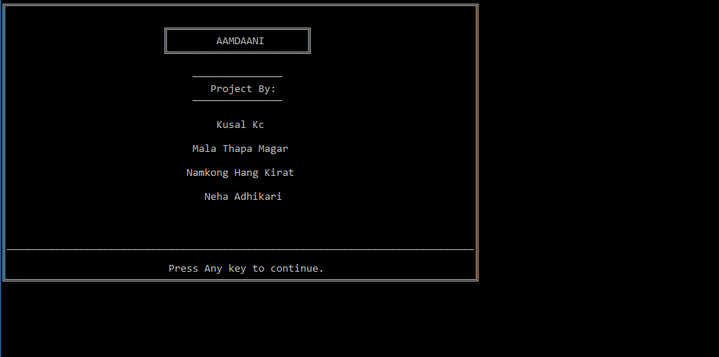

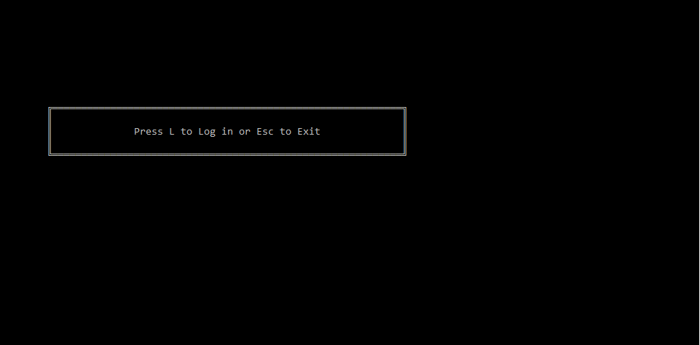

24

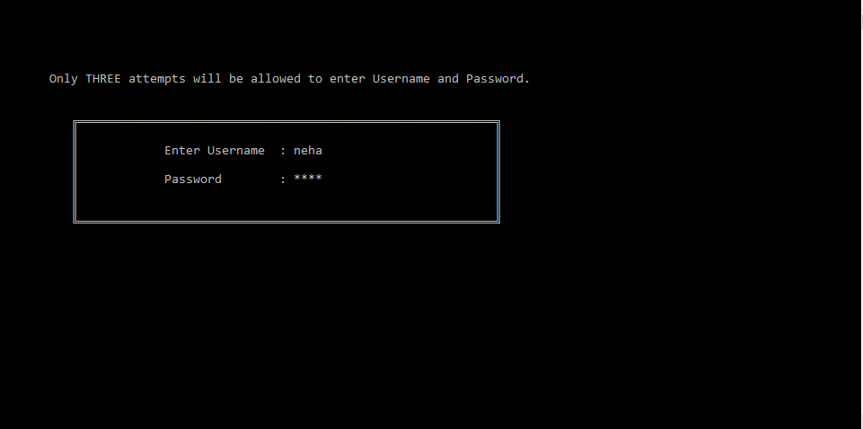

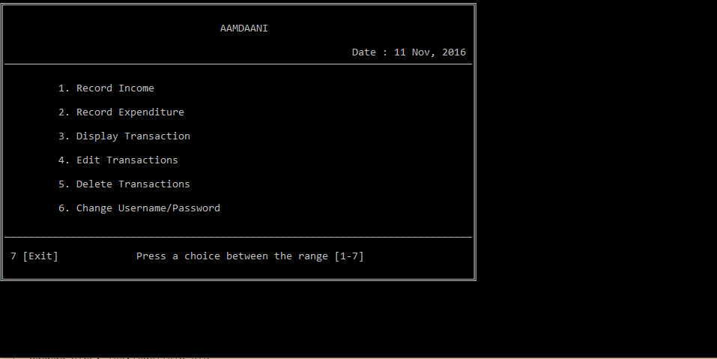

25

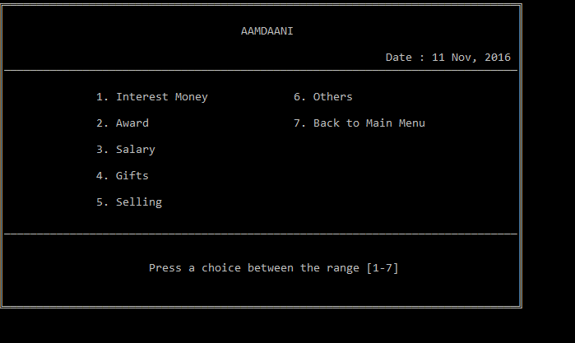

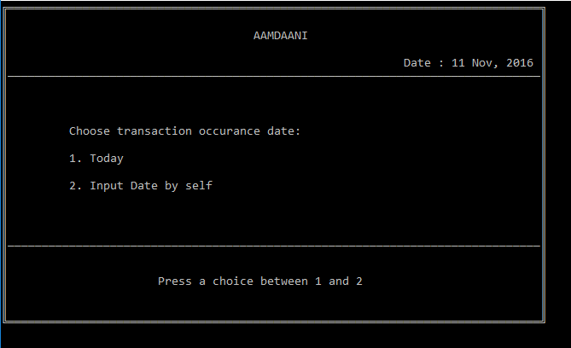

26

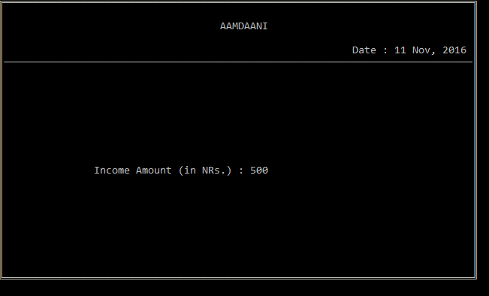

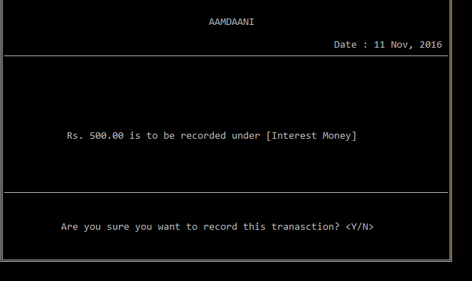

27

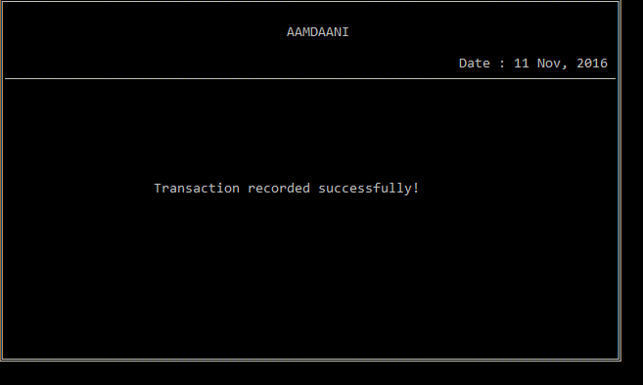

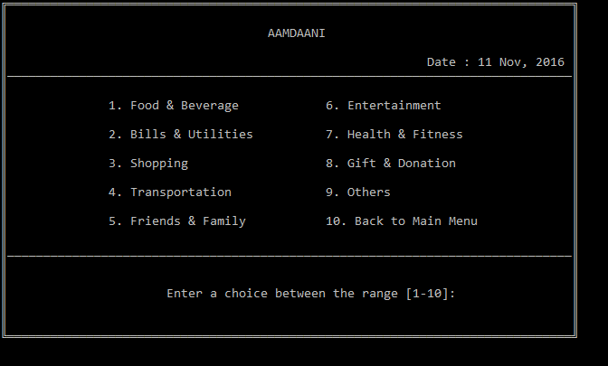

28

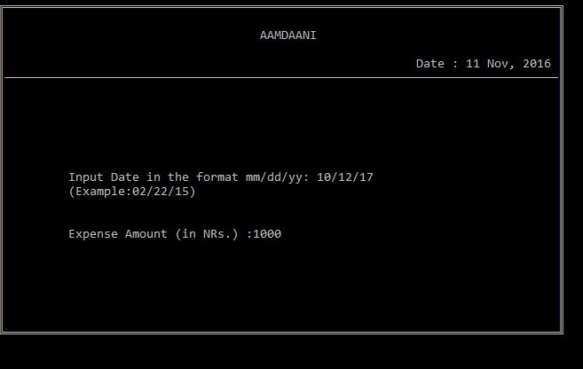

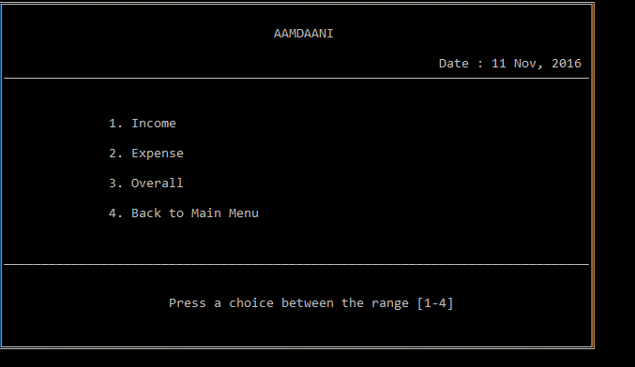

29

**Source code**

//Student Management System

//Submitted By: Kushal Kc

// Mala Thapa Magar

// Namkong Hang Kirat

// Neha Adhikari/*

//===========================================================//

#include <stdio.h>//For standard I/O Operation

#include <stdlib.h>//To use functions like system(); system("dos command"); - this performs the dos command given. Eg. system("cls"); - This command clears the screen

#include <windows.h>//Used in making gotoxy(int, int) function

#include <conio.h>//For getch(); getche() type of functions

#include <time.h>//To get system date and time

#include <ctype.h> //For isprint() type of functions.

#include <math.h>//To calculate mathematical problems, used esp. in interest calculation

struct trans//Structure for storing transaction information

{

char t_type[25],_date[15],_ttime[10];

float amt;

30

int c;

};

struct user//Structure for storing User information

{

char name[30], password[30];

};

FILE *fp,*tfp,*fp1;

char date[13],ttime[10];

int inputc=1,outputc=1; //Miscellaneous Functions

void gotoxy(int x,int y); //To move the cursor to x column and y row of output screen

void _password(char buffer[]);// To input password from user so that asterik (*) is displayed for each character entered. Similar to gets(string); function

void rectangle(int x,int y,int l,int b);// To make a rectangle starting from (x,y) with length l and breadth b

void currency(char cur[], float n); // To convert a floating number n into currency format in Hindu Arabic Number system. Eg. on execution of the statement currency(cur,123456.789); the value of cur will be "1,23,456.78"

void date_output(char date[]); //To convert date in format mm/dd/yy to dd MMM, yyyy. Eg. 01/01/11 is changed to 01 Jan, 2011

31

void welcome();// Displays welcome screen that you see as soon as program is executed

void title(); //Clears the screen and displays program title and Current date on top of Screen

//Main Functions

void user();//Window to login to enter main menu of the program

void main_menu(); //Main menu of the program

void rec_inc(); //To record transaction regardina income

void rec_exp(); //TO recored transaction regarding expenditure

void display(); //TO display overall transaction

void tran_delete(); //To delete transaction

void tran_edit(); //To edit transaction

void edit(); //To edit username and password

//Sub Functions

void disp_main(int); //Main function to display transaction

void tran_main_inc(int); //Main function to record income transaction

void tran_main_exp(int); //Main function to record expense transaction

int main()

{

char c;

32

welcome(); //Welcome sreen at beginning

do

{

system("cls"); //Clears the screen

rectangle(8,9,70,13);

gotoxy(23,11); printf("Press L to Log in or Esc to Exit");

c=getche(); //Variable c stores the key pressed by user

if (c=='L'||c=='l')

{

user();

break;

}

if (c==27) exit(0); //27 is ASCII code of escape key, means program exits when user presses Esc key insted to A or S

}while(1); //infinite loop incase any key other than Esc or L is pressed

return 0;

}

void user()

33

{

int i,ch; //Log in Screen begins...

char pass[30],nam[30];

int cnt,c;

struct user user;

cnt=0;//This variable cnt counts the number of attempts of Log in

do

{

system("cls");

rectangle(10,8,70,15);

gotoxy(7,5);printf("Only THREE attempts will be allowed to enter Username and Password.");

gotoxy(23,10); printf("Enter Username : "); gets(user.name);

gotoxy(23,12); printf("Password : ");

_password(user.password);

if (cnt==2)// when no of attempts exceeds 3 (0, 1 & 2)

{

title();

gotoxy(15,10); printf("You have entered wrong username and/or password three times.\n");

34

gotoxy(24,12);printf("Press ENTER to exit the program.");

getch();

exit(0);

}

fp=fopen("USER.DAT","r");

while(fscanf(fp,"%s %s\n",nam,pass)!=EOF)

{

if((strcmp(user.name,nam)==0)&&(strcmp(user.password,pass)==0))

{

c = 1;

}

}

cnt++; //if the combination doesn't match error text is shown and cnt is increased

fclose(fp);

title();

if(c==1)

{main_menu();} //main menu of the program is prompted

else

35

{

title();

gotoxy(25,10); printf("Invalid Username and/or Password!\a");

gotoxy(28,12);printf("Press ENTER to try again.");

getch();

}

} while(1);//not exactly infinite as user is prompted only maximum three times.

}

void main_menu()

{

int i;

char ex;

\system("cls");

do

{

title(); //Displays title and date at the top

gotoxy(10,7); printf("1. Record Income");

gotoxy(10,9); printf("2. Record Expenditure");

36

gotoxy(10,11); printf("3. Display Transaction");

gotoxy(10,13); printf("4. Edit Transactions");

gotoxy(10,15); printf("5. Delete Transactions");

gotoxy(10,17); printf("6. Change Username/Password");

gotoxy(2,21); printf("7 [Exit]");

gotoxy(1,19); for(i=0;i<78;i++) printf("_"); //prints long line of "_" to separate menu and choice input

gotoxy(23,21); printf("Press a choice between the range [1-7] ");

switch(getch()-48) //getch gets the int value of "charater" 1 to 5, to convert it to respective integer we subtract it by 48

{

case 1:rec_inc();

break;

case 2:rec_exp();

break;

case 3:display();

break;

case 4:tran_edit();

37

break;

case 5:tran_delete();

break;

case 6:edit();

break;

case 7:

{

title();

gotoxy(15,14); printf("Are you sure you want to exit? <Y/N> : ");

ex=getche();

if (ex=='Y'||ex=='y')

exit(0);

else

break;

}

default://when entered characted is not between 1-6

{

title();

gotoxy(12,12); printf("Your input is out of range! Enter a choice between 1 to 6!");

38

gotoxy(26,15); printf("Press any key to continue");

getch();

}

}

}while(1);//infinite loop to return to main menu after execution of any function

//return 0;

}

void rec_inc()

{

int i, type; //int type helps to determine the topic of transaction in the function tran_main_inc(type)

title();

gotoxy(15,7); printf("1. Interest Money\n");

gotoxy(15,9); printf("2. Award\n");

gotoxy(15,11); printf("3. Salary\n");

gotoxy(15,13); printf("4. Gifts\n");

gotoxy(15,15); printf("5. Selling\n");

gotoxy(45,7); printf("6. Others\n");

gotoxy(45,9); printf("7. Back to Main Menu\n");

gotoxy(1,17); for(i=0;i<78;i++) printf("_");

39

gotoxy(23,20); printf("Press a choice between the range [1-7] ");

switch(getch()-48)

{

case 1:type=1;tran_main_inc(type); //it calls function whic records income transaction

break;

case 2:type=2;tran_main_inc(type);

break;

case 3:type=3;tran_main_inc(type);

break;

case 4:type=4;tran_main_inc(type);

break;

case 5:type=5;tran_main_inc(type);

break;

case 6:type=6;tran_main_inc(type);

break;

case 7:

break;

default://when entered characted is not between 1-7

title();

40

gotoxy(12,12); printf("Your input is out of range! Enter a choice between 1 to 7!");

gotoxy(26,15); printf("Press any key to continue");

getch();

}

}

void rec_exp()

{

int i,sw,type; //int type helps to determine the topic of transaction in the function tran_main_exp(type)

title();

gotoxy(15,7); printf("1. Food & Beverage\n");

gotoxy(15,9); printf("2. Bills & Utilities\n");

gotoxy(15,11); printf("3. Shopping\n");

gotoxy(15,13); printf("4. Transportation\n");

gotoxy(15,15); printf("5. Friends & Family\n");

gotoxy(45,7); printf("6. Entertainment\n");

gotoxy(45,9); printf("7. Health & Fitness\n");

gotoxy(45,11); printf("8. Gift & Donation\n");

gotoxy(45,13); printf("9. Others\n");

gotoxy(45,15); printf("10. Back to Main Menu\n");

41

gotoxy(1,17); for(i=0;i<78;i++) printf("_");

gotoxy(23,20); printf("Enter a choice between the range [1-10]: ");

scanf("%d",&sw);

switch(sw)

{

case 1:type=1;tran_main_exp(type); //it calls a function which records expense transaction of type 1 ie.Food & Beverage

break;

case 2:type=2;tran_main_exp(type); //it calls a function which records expense transaction of type 2 ie.Bills & Utilities....etc

break;

case 3:type=3;tran_main_exp(type);

break;

case 4:type=4;tran_main_exp(type);

break;

case 5:type=5;tran_main_exp(type);

break;

case 6:type=6;tran_main_exp(type);

break;

case 7:type=7;tran_main_exp(type);

42

break;

case 8:type=8;tran_main_exp(type);

break;

case 9:type=9;tran_main_exp(type);

break;

case 10:

break;

default://when entered characted is not between 1-10

{title();

gotoxy(12,12); printf("Your input is out of range! Enter a choice between 1 to 10!");

gotoxy(26,15); printf("Press any key to continue");

getch();}

}

}

void display()

{

int i, type;

title();

gotoxy(15,8);printf("1. Income\n");

43

gotoxy(15,10);printf("2. Expense\n");

gotoxy(15,12);printf("3. Overall\n");

gotoxy(15,14);printf("4. Back to Main Menu\n");

gotoxy(1,17); for(i=0;i<78;i++) printf("_");

gotoxy(23,20);printf("Press a choice between the range [1-4] ");

switch(getch()-48)

{

case 1:type=1;disp_main(type); //it calls main display function which displays total incomes

break;

case 2:type=2;disp_main(type); //it calls main display function which displays total expenses

break;

case 3:type=3;disp_main(type); //it calls main display function which displays overall transactions

break;

case 4: break;

44

default://when entered characted is not between 1-8

{title();

gotoxy(12,12); printf("Your input is out of range! Enter a choice between 1 to 4!"); gotoxy(26,15); printf("Press any key to continue");

getch();}

}

}

void edit(){

Char nam[30], pass[30],ch, n_nam[30], n_pass[30]={0},passwrd[30]={0},n_pass1[30]={0};

struct user user;

int c=0,err=0;

title();

gotoxy(25,8);printf("User Name : ");

scanf("%s",user.name);

gotoxy(25,10);printf("Password : ");

_password(passwrd);

strcpy(user.password,passwrd);

fp=fopen("USER.DAT","r");

45

while(fscanf(fp,"

%s %s\n",nam,pass)!=EOF) //opeans USER.DAT and reads the content

{

if(strcmp(user.name,nam)==0&&strcmp(user.password,pass)==0) c++; //if input username and password matches c is increased

}

fclose(fp);

title();

if (c==0) //input username and password didn't match so c is not increased hence c=0

{

gotoxy(22,10); printf("Wrong Username and/or Password\a");

getch();

}

else

{

gotoxy(8,10); printf("Are you sure you want to CHANGE user name and/or password? <Y/N> : ");

46

ch=getche();

if(ch=='Y'||ch=='y')

{

do

{

title();

err=0;

gotoxy(25,8);

printf("NEW Username : ");

scanf("%s",n_nam);

gotoxy(25,10);

printf("NEW Password : ");

_password(n_pass);

gotoxy(25,12);

printf("Confirm NEW Password : ");

_password(n_pass1);

if (strcmp(n_pass,n_pass1)!=0) //comparing string of password and string of confirm password

{

47

title();

gotoxy(17,13);

printf("Password and confirm password does not match!\a");

getch();

err++;

}

} while(err!=0);

tfp=fopen("TEMP.DAT","a"); //opeans a temporary file

fprintf(tfp,"%s %s\n",n_nam,n_pass); //prints the new username pad password in it

fclose(tfp);

fclose(fp);

remove("USER.DAT"); //delete the old USER.DAT file

rename("TEMP.DAT","USER.DAT"); //rename the TEMP.DAT into USER.DAT

title();

gotoxy(21,13); printf("Record has been EDITED successfully!");

getch();

}

48

}

}

void tran_delete()

{

struct trans trans;

char ch,curr[35];

int c,i,j=1,k=0;

title();

gotoxy(15,10);printf("1. Delete Income Transaction\n");

gotoxy(15,12);printf("2. Delete Expense Transaction\n");

gotoxy(15,14);printf("3. Back to Main Menu\n");

gotoxy(1,17); for(i=0;i<78;i++) printf("_");

gotoxy(23,20);printf("Press a choice between the range [1-3] ");

switch(getch()-48)

{

case 1:

title();

gotoxy(2,6);puts("S.N.");

49

gotoxy(8,6);puts("Transaction Type");

gotoxy(36,6);puts("Date");

gotoxy(50,6);puts("Time");

gotoxy(61,6);puts("Amount (NRs.)");

gotoxy(1,7); for(i=1;i<79;i++) printf("%c",196);

fp=fopen("INCOME_T.DAT","r");

while(fread(&trans,sizeof(trans),1,fp)==1)

{

gotoxy(2,8+j);printf("%d.",trans.c);

gotoxy(8,8+j);printf("%s",trans.t_type);

strcpy(date,trans._date);

date_output(date);

gotoxy(36,8+j);printf("%s",date);

gotoxy(50,8+j);printf("%s",trans._ttime);

currency(curr,trans.amt);

gotoxy(61,8+j);printf("%s",curr);

j++;

}

50

fclose(fp);

gotoxy(1,20); for(i=0;i<78;i++) printf("_");

gotoxy(3,22);printf("Enter transaction no. to delete or press any other key to go back: ");

scanf("%d",&c);

fp=fopen("INCOME_T.DAT","r");

tfp=fopen("TEMP.DAT","w");

while(fread(&trans,sizeof(trans),1,fp)==1)

{

if(c==trans.c)

{title();

gotoxy(20,12);printf("Transaction has been sucessfully deleted!");

k=1;

getch();

}

else{

fwrite(&trans,sizeof(trans),1,tfp);

}

}

fclose(fp);

51

fclose(tfp);

remove("INCOME_T.DAT");

rename("TEMP.DAT","INCOME_T.DAT");

fp=fopen("INCOME_T.DAT","r");

tfp=fopen("TEMP.DAT","w");

while(fread(&trans,sizeof(trans),1,fp)==1)

{

if(trans.c<c)

{

fwrite(&trans,sizeof(trans),1,tfp);

}

else if(c<trans.c)

{

trans.c--;

fwrite(&trans,sizeof(trans),1,tfp);

}

}

fclose(fp);

52

fclose(tfp);

remove("INCOME_T.DAT");

rename("TEMP.DAT","INCOME_T.DAT");

break;

case 2:

title();

gotoxy(2,6);puts("S.N.");

gotoxy(8,6);puts("Transaction Type");

gotoxy(36,6);puts("Date");

gotoxy(50,6);puts("Time");

gotoxy(61,6);puts("Amount (NRs.)");

gotoxy(1,7); for(i=1;i<79;i++) printf("%c",196);

fp=fopen("EXPENSE_T.DAT","r");

while(fread(&trans,sizeof(trans),1,fp)==1)

{

gotoxy(2,8+j);printf("%d.",trans.c);

53

gotoxy(8,8+j);printf("%s",trans.t_type);

strcpy(date,trans._date);

date_output(date);

gotoxy(36,8+j);printf("%s",date);

gotoxy(50,8+j);printf("%s",trans._ttime);

currency(curr,trans.amt);

gotoxy(61,8+j);printf("%s",curr);

j++;

}

fclose(fp);

gotoxy(1,20); for(i=0;i<78;i++) printf("_");

gotoxy(3,22);printf("Enter transaction no. to delete or press any other key to go back: ");

scanf("%d",&c);

fp=fopen("EXPENSE_T.DAT","r");

tfp=fopen("TEMP.DAT","w");

while(fread(&trans,sizeof(trans),1,fp)==1)

{

if(c==trans.c)

{title();

54

gotoxy(20,12);printf("Transaction has been sucessfully deleted!");

k=1;

getch();

}

else{

fwrite(&trans,sizeof(trans),1,tfp);

}

}

fclose(fp);

fclose(tfp);

remove("EXPENSE_T.DAT");

rename("TEMP.DAT","EXPENSE_T.DAT");

fp=fopen("EXPENSE_T.DAT","r");

tfp=fopen("TEMP.DAT","w");

while(fread(&trans,sizeof(trans),1,fp)==1)

{

if(trans.c<c)

{

55

fwrite(&trans,sizeof(trans),1,tfp);

}

else if(c<trans.c)

{

trans.c--;

fwrite(&trans,sizeof(trans),1,tfp);

}

}

fclose(fp);

fclose(tfp);

remove("EXPENSE_T.DAT");

rename("TEMP.DAT","EXPENSE_T.DAT");

break;

case 3:

break;

default://when entered characted is not between 1-3

{title();

gotoxy(12,12); printf("Your input is out of range! Enter a choice between 1 to 3!");

gotoxy(26,15); printf("Press any key to continue");

56

getch();

tran_delete();}

}

}

void tran_edit()

{

struct trans trans;

char ch,curr[35];

int c,i,j=1,k=0;

title();

gotoxy(15,10);printf("1. Edit Income Transaction\n");

gotoxy(15,12);printf("2. Edit Expense Transaction\n");

gotoxy(15,14);printf("3. Back to Main Menu\n");

gotoxy(1,17); for(i=0;i<78;i++) printf("_");

gotoxy(23,20);printf("Press a choice between the range [1-3] ");

switch(getch()-48)

{

case 1:

57

title();

gotoxy(2,6);puts("S.N.");

gotoxy(8,6);puts("Transaction Type");

gotoxy(36,6);puts("Date");

gotoxy(50,6);puts("Time");

gotoxy(61,6);puts("Amount (NRs.)");

gotoxy(1,7); for(i=1;i<79;i++) printf("%c",196);

fp=fopen("INCOME_T.DAT","r");

while(fread(&trans,sizeof(trans),1,fp)==1)

{

gotoxy(2,8+j);printf("%d.",trans.c);

gotoxy(8,8+j);printf("%s",trans.t_type);

strcpy(date,trans._date);

date_output(date);

gotoxy(36,8+j);printf("%s",date);

gotoxy(50,8+j);printf("%s",trans._ttime);

currency(curr,trans.amt);

gotoxy(61,8+j);printf("%s",curr);

58

j++;

}

fclose(fp);

gotoxy(1,20); for(i=0;i<78;i++) printf("_");

gotoxy(3,22);printf("Enter transaction no. to edit or press any other key to go back: ");

scanf("%d",&c);

fp=fopen("INCOME_T.DAT","r");

tfp=fopen("TEMP.DAT","w");

while(fread(&trans,sizeof(trans),1,fp)==1)

{

if(c==trans.c)

{ title();

gotoxy(15,10);printf("1. Edit Transaction Type\n");

gotoxy(15,12);printf("2. Edit Date\n");

gotoxy(15,14);printf("3. Back Amount\n");

gotoxy(1,17); for(i=0;i<78;i++) printf("_");

gotoxy(23,20);printf("Press a choice between the range [1-3] ");

switch(getch()-48)

{

59

case 1:

title();

gotoxy(15,7); printf("1. Interest Money\n");

gotoxy(15,9); printf("2. Award\n");

gotoxy(15,11); printf("3. Salary\n");

gotoxy(15,13); printf("4. Gifts\n");

gotoxy(15,15); printf("5. Selling\n");

gotoxy(45,7); printf("6. Others\n");

gotoxy(1,17); for(i=0;i<78;i++) printf("_");

gotoxy(23,20); printf("Press a choice between the range [1-6] ");

switch(getch()-48)

{

case 1: strcpy(trans.t_type,"Interest Money"); break;

case 2: strcpy(trans.t_type,"Award"); break;

case 3: strcpy(trans.t_type,"Salary"); break;

case 4: strcpy(trans.t_type,"Gifts"); break;

case 5: strcpy(trans.t_type,"Selling"); break;

case 6: strcpy(trans.t_type,"Others"); break;

}

60

fwrite(&trans,sizeof(trans),1,tfp);

title();

gotoxy(20,12);printf("Transaction has been sucessfully Edited!");

getch();

break;

case 2:

title();

gotoxy(10,12);printf("Input Date in the format mm/dd/yy:");

gotoxy(10,13);printf("(Example:02/22/15)");

gotoxy(45,12);scanf("%s",&trans._date);

fwrite(&trans,sizeof(trans),1,tfp);

title();

gotoxy(20,12);printf("Transaction has been sucessfully Edited!");

getch();

break;

case 3:

title();

gotoxy(10,13);printf("Input Amount (in NRs.):");

gotoxy(35,13);scanf("%f",&trans.amt);

61

fwrite(&trans,sizeof(trans),1,tfp);

title();

gotoxy(20,12);printf("Transaction has been sucessfully Edited!");

getch();

break;

}

}

else{

fwrite(&trans,sizeof(trans),1,tfp);

}

}

fclose(fp);

fclose(tfp);

remove("INCOME_T.DAT");

rename("TEMP.DAT","INCOME_T.DAT");

break;

case 2:

title();

gotoxy(2,6);puts("S.N.");

62

gotoxy(8,6);puts("Transaction Type");

gotoxy(36,6);puts("Date");

gotoxy(50,6);puts("Time");

gotoxy(61,6);puts("Amount (NRs.)");

gotoxy(1,7); for(i=1;i<79;i++) printf("%c",196);

fp=fopen("EXPENSE_T.DAT","r");

while(fread(&trans,sizeof(trans),1,fp)==1)

{

gotoxy(2,8+j);printf("%d.",trans.c);

gotoxy(8,8+j);printf("%s",trans.t_type);

strcpy(date,trans._date);

date_output(date);

gotoxy(36,8+j);printf("%s",date);

gotoxy(50,8+j);printf("%s",trans._ttime);

currency(curr,trans.amt);

gotoxy(61,8+j);printf("%s",curr);

j++;

}

63

fclose(fp);

gotoxy(1,20); for(i=0;i<78;i++) printf("_");

gotoxy(3,22);printf("Enter transaction no. to edit or press other key to go back: ");

scanf("%d",&c);

fp=fopen("EXPENSE_T.DAT","r");

tfp=fopen("TEMP.DAT","w");

while(fread(&trans,sizeof(trans),1,fp)==1)

{

if(c==trans.c)

{ title();

gotoxy(15,10);printf("1. Edit Transaction Type\n");

gotoxy(15,12);printf("2. Edit Date\n");

gotoxy(15,14);printf("3. Back Amount\n");

gotoxy(1,17); for(i=0;i<78;i++) printf("_");

gotoxy(23,20);printf("Press a choice between the range [1-3] ");

switch(getch()-48)

{

case 1:

title();

64

gotoxy(15,7); printf("1. Food & Beverage\n");

gotoxy(15,9); printf("2. Bills & Utilities\n");

gotoxy(15,11); printf("3. Shopping\n");

gotoxy(15,13); printf("4. Transportation\n");

gotoxy(15,15); printf("5. Friends & Family\n");

gotoxy(45,7); printf("6. Entertainment\n");

gotoxy(45,9); printf("7. Health & Fitness\n");

gotoxy(45,11); printf("8. Gift & Donation\n");

gotoxy(45,13); printf("9. Others\n");

gotoxy(1,17); for(i=0;i<78;i++) printf("_");

gotoxy(23,20);printf("Press a choice between the range [1-9] ");

switch(getch()-48)

{

case 1: strcpy(trans.t_type,"Food & Beverage"); break;

case 2: strcpy(trans.t_type,"Bills & Utilities"); break;

case 3: strcpy(trans.t_type,"Shopping"); break;

case 4: strcpy(trans.t_type,"Transportation"); break;

case 5: strcpy(trans.t_type,"Friends & Family"); break;

case 6: strcpy(trans.t_type,"Entertainment"); break;

65

case 7: strcpy(trans.t_type,"Health & Fitness"); break;

case 8: strcpy(trans.t_type,"Gift & Donation"); break;

case 9: strcpy(trans.t_type,"Others"); break;

}

fwrite(&trans,sizeof(trans),1,tfp);

title();

gotoxy(20,12);printf("Transaction has been sucessfully Edited!");

getch();

break;

case 2:

title();

gotoxy(10,12);printf("Input Date in the format mm/dd/yy:");

gotoxy(10,13);printf("(Example:02/22/15)");

gotoxy(45,12);scanf("%s",&trans._date);

fwrite(&trans,sizeof(trans),1,tfp);

title();

gotoxy(20,12);printf("Transaction has been sucessfully Edited!");

getch();

break;

66

case 3:

title();

gotoxy(10,13);printf("Input Amount (in NRs.):");

gotoxy(35,13);scanf("%f",&trans.amt);

fwrite(&trans,sizeof(trans),1,tfp);

title();

gotoxy(20,12);printf("Transaction has been sucessfully Edited!");

getch();

break;

}

}

else{

fwrite(&trans,sizeof(trans),1,tfp);

}

}

fclose(fp);

fclose(tfp);

remove("EXPENSE_T.DAT");

rename("TEMP.DAT","EXPENSE_T.DAT");

67

break;

case 3:

break;

default://when entered characted is not between 1-3

{title();

gotoxy(12,12); printf("Your input is out of range! Enter a choice between 1 to 3!");

gotoxy(26,15); printf("Press any key to continue");

getch();}

}

}

//----------------------------------------------//

void tran_main_inc(int type)

{

struct trans trans;

char ch,curr[35];

int i;

fp=fopen("INCOME_T.DAT","r");

while(fread(&trans,sizeof(trans),1,fp)==1)

68

{

if(inputc<=trans.c) //to check the transaction counter and increase by 1

inputc++;

}

fclose(fp);

trans.c=inputc;

switch(type)

{

case 1: strcpy(trans.t_type,"Interest Money"); break;

case 2: strcpy(trans.t_type,"Award"); break;

case 3: strcpy(trans.t_type,"Salary"); break;

case 4: strcpy(trans.t_type,"Gifts"); break;

case 5: strcpy(trans.t_type,"Selling"); break;

case 6: strcpy(trans.t_type,"Others"); break;

}

title();

gotoxy(10,9);printf("Choose transaction occurance date:");

gotoxy(10,11);printf("1. Today");

69

gotoxy(10,13);printf("2. Input Date by self");

gotoxy(1,17); for(i=0;i<78;i++) printf("_");

gotoxy(23,20);printf("Press a choice between 1 and 2 ");

switch(getch()-48)

{

case 1:

{

title();

_strdate(date);

strcpy(trans._date,date);

_strtime(ttime);

strcpy(trans._ttime,ttime);

gotoxy(16,14);printf("Income Amount (in NRs.) : "); scanf("%f",&trans.amt);

title();

currency(curr,trans.amt); //calls currency function which converts eg. "1234" to "Rs. 1,234"

gotoxy(12,12); printf("%s is to be recorded under [%s] ",curr,trans.t_type); //

gotoxy(1,17); for(i=0;i<78;i++) printf("%c",196);

70

gotoxy(11,20);printf("Are you sure you want to record this tranasction? <Y/N>");

ch=getche();

if (ch=='Y'||ch=='y')

{

fp=fopen("INCOME_T.DAT","a");

fwrite(&trans,sizeof(trans),1,fp);

fclose(fp);

title();

gotoxy(20,12);printf("Transaction recorded successfully!");

getch();

}

break;

}

case 2:

{

title();

gotoxy(10,12);printf("Input Date in the format mm/dd/yy:");

gotoxy(10,13);printf("(Example:02/22/15)");

gotoxy(10,16);printf("Income Amount (in NRs.) : ");

71

gotoxy(45,12);scanf("%s",&trans._date);

gotoxy(36,16);scanf("%f",&trans.amt);

_strtime(ttime);

strcpy(trans._ttime,ttime);

title();

currency(curr,trans.amt);

gotoxy(12,12); printf("%s is to be recorded under [%s] ",curr,trans.t_type);

gotoxy(1,17); for(i=0;i<78;i++) printf("%c",196);

gotoxy(11,20);printf("Are you sure you want to record this tranasction? <Y/N>");

ch=getche();

if (ch=='Y'||ch=='y')

{

fp=fopen("INCOME_T.DAT","a");

fwrite(&trans,sizeof(trans),1,fp);

fclose(fp);

title();

gotoxy(20,12);printf("Transaction recorded successfully!");

getch();

}

72

break;

}

default://when entered characted is not 1 or 2

{title();

gotoxy(27,12); printf("Your input is out of range!");

gotoxy(26,15); printf("Press any key to continue");

getch();

tran_main_inc(type);}

}

}

void tran_main_exp(int type)

{

struct trans trans;

char ch,curr[35];

int i;

fp=fopen("EXPENSE_T.DAT","r");

while(fread(&trans,sizeof(trans),1,fp)==1)

{

73

if(outputc<=trans.c)

outputc++;

}

fclose(fp);

trans.c=outputc;

switch(type)

{

case 1: strcpy(trans.t_type,"Food & Beverage"); break;

case 2: strcpy(trans.t_type,"Bills & Utilities"); break;

case 3: strcpy(trans.t_type,"Shopping"); break;

case 4: strcpy(trans.t_type,"Transportation"); break;

case 5: strcpy(trans.t_type,"Friends & Family"); break;

case 6: strcpy(trans.t_type,"Entertainment"); break;

case 7: strcpy(trans.t_type,"Health & Fitness"); break;

case 8: strcpy(trans.t_type,"Gift & Donation"); break;

case 9: strcpy(trans.t_type,"Others"); break;

}

title();

74

gotoxy(10,9);printf("Choose transaction occurance date:");

gotoxy(10,11);printf("1. Today");

gotoxy(10,13);printf("2. Input Date by self");

gotoxy(1,17); for(i=0;i<78;i++) printf("_");

gotoxy(23,20);printf("Press a choice between 1 and 2 ");

switch(getch()-48)

{

case 1:

{

title();

_strdate(date);

strcpy(trans._date,date);

_strtime(ttime);

strcpy(trans._ttime,ttime);

gotoxy(16,14);printf("Expense Amount (in NRs.) : "); scanf("%f",&trans.amt);

title();

currency(curr,trans.amt);

gotoxy(12,12); printf("%s is to be recorded under [%s] ",curr,trans.t_type);

gotoxy(1,17); for(i=0;i<78;i++) printf("%c",196);

75

gotoxy(11,20);printf("Are you sure you want to record this tranasction? <Y/N>");

ch=getche();

if (ch=='Y'||ch=='y')

{

fp=fopen("EXPENSE_T.DAT","a");

fwrite(&trans,sizeof(trans),1,fp);

fclose(fp);

title();

gotoxy(20,12);printf("Transaction recorded successfully!");

getch();

}

break;

}

case 2:

{

title();

gotoxy(10,12);printf("Input Date in the format mm/dd/yy:");

gotoxy(10,13);printf("(Example:02/22/15)");

76

gotoxy(10,16);printf("Expense Amount (in NRs.) : ");

gotoxy(45,12);scanf("%s",&trans._date);

gotoxy(36,16);scanf("%f",&trans.amt);

_strtime(ttime);

strcpy(trans._ttime,ttime);

title();

currency(curr,trans.amt);

gotoxy(12,12); printf("%s is to be recorded under [%s] ",curr,trans.t_type);

gotoxy(1,17); for(i=0;i<78;i++) printf("%c",196);

gotoxy(11,20);printf("Are you sure you want to record this tranasction? <Y/N>");

ch=getche();

if (ch=='Y'||ch=='y')

{

fp=fopen("EXPENSE_T.DAT","a");

fwrite(&trans,sizeof(trans),1,fp);

fclose(fp);

title();

gotoxy(20,12);printf("Transaction recorded successfully!");

getch();

77

rec_exp();

}

break;

}

default://when entered characted is not 1 or 2

{title();

gotoxy(27,12); printf("Your input is out of range!");

gotoxy(26,15); printf("Press any key to continue");

getch();

tran_main_exp(type);

}

}

}

void disp_main(int type)

{

struct trans trans;

char ch,curr[35];

int c,i,j=1;

78

float totalam=0,totalam1=0;

float in1=0,in2=0,in3=0,in4=0,in5=0,in6=0;

float ou1=0,ou2=0,ou3=0,ou4=0,ou5=0,ou6=0,ou7=0,ou8=0,ou9=0;

switch(type)

{

case 1:

{

title();

gotoxy(2,6);puts("S.N.");

gotoxy(8,6);puts("Transaction Type");

gotoxy(36,6);puts("Date");

gotoxy(50,6);puts("Time");

gotoxy(61,6);puts("Amount (NRs.)");

gotoxy(1,7); for(i=1;i<79;i++) printf("%c",196);

fp=fopen("INCOME_T.DAT","r");

while(fread(&trans,sizeof(trans),1,fp)==1)

{

79

gotoxy(2,8+j);printf("%d.",trans.c);

gotoxy(8,8+j);printf("%s",trans.t_type);

strcpy(date,trans._date);

date_output(date);

gotoxy(36,8+j);printf("%s",date);

gotoxy(50,8+j);printf("%s",trans._ttime);

currency(curr,trans.amt);

gotoxy(61,8+j);printf("%s",curr);

totalam=totalam+trans.amt;

j++;

}

fclose(fp);

gotoxy(1,20); for(i=0;i<78;i++) printf("_");

gotoxy(3,22);printf("Press Backspace to go Back.");

gotoxy(45,22);puts("Total Income: ");

currency(curr,totalam);

gotoxy(60,22);printf("%s",curr);

c=getch();

if(c==8)

80

display();

else

disp_main(type);

break;

}

case 2:

{

title();

gotoxy(2,6);puts("S.N.");

gotoxy(8,6);puts("Transaction Type");

gotoxy(36,6);puts("Date");

gotoxy(50,6);puts("Time");

gotoxy(61,6);puts("Amount (NRs.)");

gotoxy(1,7); for(i=1;i<79;i++) printf("%c",196);

fp=fopen("EXPENSE_T.DAT","r");

while(fread(&trans,sizeof(trans),1,fp)==1)

{

81

gotoxy(2,8+j);printf("%d.",trans.c);

gotoxy(8,8+j);printf("%s",trans.t_type);

strcpy(date,trans._date);

date_output(date);

gotoxy(36,8+j);printf("%s",date);

gotoxy(50,8+j);printf("%s",trans._ttime);

currency(curr,trans.amt);

gotoxy(61,8+j);printf("%s",curr);

totalam=totalam+trans.amt;

j++;

}

fclose(fp);

gotoxy(1,20); for(i=0;i<78;i++) printf("_");

gotoxy(3,22);printf("Press Backspace to go Back.");

gotoxy(45,22);puts("Total Expense: ");

currency(curr,totalam);

gotoxy(61,22);printf("%s",curr);

c=getch();

if(c==8)

82

display();

else

disp_main(type);

break;

}

case 3: {

title();

gotoxy(18,7);printf("INCOME");

gotoxy(58,7);printf("EXPENSE");

fp=fopen("INCOME_T.DAT","r");

while(fread(&trans,sizeof(trans),1,fp)==1)

{

if(strcmp("Interest Money",trans.t_type)==0) in1=in1+trans.amt;

else if(strcmp("Award",trans.t_type)==0) in2=in2+trans.amt;

else if(strcmp("Salary",trans.t_type)==0) in3=in3+trans.amt;

else if(strcmp("Gifts",trans.t_type)==0) in4=in4+trans.amt;

else if(strcmp("Selling",trans.t_type)==0) in5=in5+trans.amt;

else if(strcmp("Others",trans.t_type)==0) in6=in6+trans.amt;

}

83

gotoxy(3,9); printf("1. Interest Money\n");

currency(curr,in1);

gotoxy(21,9);printf(": %s",curr);

gotoxy(3,10); printf("2. Award\n");

currency(curr,in2);

gotoxy(21,10);printf(": %s",curr);

gotoxy(3,11); printf("3. Salary\n");

currency(curr,in3);

gotoxy(21,11);printf(": %s",curr);

gotoxy(3,12); printf("4. Gifts\n");

currency(curr,in4);

gotoxy(21,12);printf(": %s",curr);

gotoxy(3,13); printf("5. Selling\n");

currency(curr,in5);

gotoxy(21,13);printf(": %s",curr);

gotoxy(3,14); printf("6. Others\n");

currency(curr,in6);

gotoxy(21,14);printf(": %s",curr);

totalam=in1+in2+in3+in4+in5+in6;

84

currency(curr,totalam);

gotoxy(6,19); printf("Total Inflow: \n");

gotoxy(20,19); printf("%s",curr);

fp=fopen("EXPENSE_T.DAT","r");

while(fread(&trans,sizeof(trans),1,fp)==1)

{

if(strcmp("Food & Beverage",trans.t_type)==0) ou1=ou1+trans.amt;

else if(strcmp("Bills & Utilities",trans.t_type)==0) ou2=ou2+trans.amt;

else if(strcmp("Shopping",trans.t_type)==0) ou3=ou3+trans.amt;

else if(strcmp("Transportation",trans.t_type)==0) ou4=ou4+trans.amt;

else if(strcmp("Friends & Family",trans.t_type)==0) ou5=ou5+trans.amt;

else if(strcmp("Entertainment",trans.t_type)==0) ou6=ou6+trans.amt;

else if(strcmp("Health & Fitness",trans.t_type)==0) ou7=ou7+trans.amt;

else if(strcmp("Gift & Donation",trans.t_type)==0) ou8=ou8+trans.amt;

else if(strcmp("Others",trans.t_type)==0) ou9=ou9+trans.amt;

}

fclose(fp);

gotoxy(40,9); printf("1. Food & Beverage");

currency(curr,ou1);

85

gotoxy(61,9);printf(": %s",curr);

gotoxy(40,10); printf("2. Bills & Utilities");

currency(curr,ou2);

gotoxy(61,10);printf(": %s",curr);

gotoxy(40,11); printf("3. Shopping");

currency(curr,ou3);

gotoxy(61,11);printf(": %s",curr);

gotoxy(40,12); printf("4. Transportation");

currency(curr,ou4);

gotoxy(61,12);printf(": %s",curr);

gotoxy(40,13); printf("5. Friends & Family");

currency(curr,ou5);

gotoxy(61,13);printf(": %s",curr);

gotoxy(40,14); printf("6. Entertainment");

currency(curr,ou6);

gotoxy(61,14);printf(": %s",curr);

gotoxy(40,15); printf("7. Health & Fitness");

currency(curr,ou7);

gotoxy(61,15);printf(": %s",curr);

86

gotoxy(40,16); printf("8. Gift & Donation");

currency(curr,ou8);

gotoxy(61,16);printf(": %s",curr);

gotoxy(40,17); printf("9. Others");

currency(curr,ou9);

gotoxy(61,17);printf(": %s",curr);

totalam1=ou1+ou2+ou3+ou4+ou5+ou6+ou7+ou8+ou9;

currency(curr,totalam1);

gotoxy(45,19); printf("Total Outflow: \n");

gotoxy(60,19); printf("%s",curr);

gotoxy(1,20); for(i=0;i<78;i++) printf("_");

gotoxy(27,22);printf("Press Backspace to go Back.");

c=getch();

if(c==8)

display();

else

disp_main(type);

break;

87

}

}

}

//--------------------------------------------------------//

void welcome()

{

int i;

system("cls");

rectangle(0,0,80,23);

rectangle(27,2,52,4);

gotoxy(36,3); printf("AAMDAANI");

gotoxy(32,6);for(i=0;i<15;i++) printf("%c",196);

gotoxy(35,7); printf("Project By:");

gotoxy(32,8);for(i=0;i<15;i++) printf("%c",196);

gotoxy(36,10); printf("Kusal Kc");

gotoxy(32,12); printf("Mala Thapa Magar");

gotoxy(31,14); printf("Namkong Hang Kirat");

gotoxy(34,16); printf("Neha Adhikari");

88

gotoxy(1,20); for(i=0;i<78;i++) printf("_");

gotoxy(28,22);

printf("Press Any key to continue.");

getch();

}

void title()

{

int i;

system("cls");

rectangle(0,0,80,23);

gotoxy(37,2);

printf("AAMDAANI");

gotoxy(59,4); printf("Date : ");

_strdate(date); //_strdate stores system date in variable date in format mm/dd/yy

date_output(date); //converts mm/dd/yy to to dd MMM, yyyy.

printf("%s",date);

89

gotoxy(1,5);

for(i=0;i<78;i++) printf("%c",196);

}

void rectangle(int x,int y,int l,int b)

{

int i,m;

gotoxy(x,y); printf("%c",201);

for(i=x+1;i<l-1;i++)

{

gotoxy(i,y);

printf("%c",205);

}

gotoxy(i,y); printf("%c",187);

for (m=y+1;m<b;m++)

{

gotoxy(x,m);

for(i=x;i<l;i++)

90

{

if(i==x||i==l-1)

{

gotoxy(i,m); printf("%c",186);

}

}

}

gotoxy(x,m); printf("%c",200);

for(i=x+1;i<l-1;i++)

{

gotoxy(i,m);

printf("%c",205);

}

gotoxy(i,m); printf("%c",188);

}

void _password(char buffer[])

91

{

char c;

int pos = 0;

do

{

c = getch();

if(isprint(c))

{

buffer[ pos++ ] = c;

printf("%c", '*');

}

else if(c == 8 && pos)

{

buffer[ pos-- ] = '\0';

printf("%s", "\b \b");

}

}while( c!= 13 );

}

92

void date_output(char date[]) //mm/dd/yy ---> dd MMM, yyyy

{

struct

{

int dd;

char mm[4];

int yyyy;

}_date;

char temp[15];

int mm,c,i;

_date.dd=(date[3]-48)*10+(date[4]-48);

mm=(date[0]-48)*10+(date[1]-48);

_date.yyyy=2000+(date[6]-48)*10+(date[7]-48);

switch(mm)

{

case 1: strcpy(_date.mm,"Jan"); break;

93

case 2: strcpy(_date.mm,"Feb"); break;

case 3: strcpy(_date.mm,"Mar"); break;

case 4: strcpy(_date.mm,"Apr"); break;

case 5: strcpy(_date.mm,"May"); break;

case 6: strcpy(_date.mm,"Jun"); break;

case 7: strcpy(_date.mm,"Jul"); break;

case 8: strcpy(_date.mm,"Aug"); break;

case 9: strcpy(_date.mm,"Sep"); break;

case 10: strcpy(_date.mm,"Oct"); break;

case 11: strcpy(_date.mm,"Nov"); break;

case 12: strcpy(_date.mm,"Dec"); break;

}

temp[0]=(int)(_date.dd/10)+48;

temp[1]=(int)(_date.dd%10)+48;

temp[2]=32;

temp[3]='\0';

strcat(temp,_date.mm);

temp[6]=',';

94

c=0;

temp[7]=32;

for(i=3;i>=0;i--)

{

temp[8+c]=(int)(_date.yyyy/pow(10,i))+48;

c++;

_date.yyyy%=(int)pow(10,i);

}

temp[12]='\0';

strcpy(date,temp);

}

void currency(char cur[], float n)

{

int num,i,x,c;

char temp[30];

num=(int)n;

int a[6];

a[5]=num%1000;

num=num/1000;

95

for(i=4;i>=0;i--)

{

a[i]=num%100;

num=num/100;

}

for(i=0;i<6;i++)

if (a[i]!=0) break;

x=i;

c=0;

for(i=x;i<6;i++)

{

if(i==5)

{

if (a[i]>=100||i!=x) cur[c++]=(a[i]/100)+48;

if (a[i]%100>=10||i!=x) cur[c++]=(a[i]%100)/10+48;

if (a[i]%100<10&&i==x) cur[c++]=48;

cur[c++]=(a[i]%100)%10+48;

}

else

96

{

if (a[i]>=10||i!=x) cur[c++]=(a[i]/10)+48;

cur[c++]=(a[i]%10)+48;

cur[c++]=',';

}

}

cur[c++]='.';

num=(n-(int)n)*100;

cur[c++]=num/10+48;

cur[c++]=num%10+48;

cur[c]='\0';

if (n==0) strcpy(cur,"0.00");

strcpy(temp,"Rs. ");

strcat(temp,cur);

strcpy(cur,temp);

}

COORD coord = {0, 0};

void gotoxy (int x, int y)

{

97

coord.X = x;

coord.Y = y; // X and Y coordinates

SetConsoleCursorPosition(GetStdHandle(STD_OUTPUT_HANDLE), coord);

}

98

**REFERENCES AND BIBLIOGRAPHY**

**References**

**Bibliography**

* <http://l.facebook.com/l.php?u=http%3A%2F%2Fcboard.cprogramming.com%2Fc-programming%2F34324-how-use-gotoxy.html&h=CAQETFHDR>
* <http://www.theasciicode.com.ar/>
* <https://www.tutorialspoint.com/c_standard_library/c_function_fread.htm>
* http://www.sanfoundry.com%2Fc-program-delete-line-text-file%2F&h=CAQETFHDR
* <https://www.tutorialspoint.com/c_standard_library/c_function_fwrite.htm>